**Software Development Project On**

**Shree Pithad Aai Wooden Furniture**

In Partial Fulfilment of Bachelor of Computer Applications (B.C.A.)

**Gujarat University (2022-23)**

Developed By

**Darshan Solanki (Uni.no-01599)**

**Parth Turakhia (Uni.no-01656)**

(Semester – V Bachelor of Computer Applications)

**P. D. PANDYA INSTITUTE OF COMPUTER APPLICATION**

P.D.Pandya College campus, Nr. Muktjivan Smruti Mandir, Ghodasar,

Ahmedabad – 382445

* Acknowledgement: -
* It really gives us a great pleasure and deep satisfaction to presenting this report of our project work as a part of BCA course arranged in order to gain the practical knowledge in system development.
* we took this opportunity to express our sincere gratitude to several people with whose help and encouragement.
* we have been able to complete this project rather successfully.
* we express a deep sense of gratitude to our internal project guide ASS.PROF Arpita Pandya for her guidance. valuable suggestion and continuous encouragement. without which the project would not have been a success.
* we also thank to our principle & our ASS.PROF Jay Desai & ASS.PROF Kajal Pandya and all other faculties of collage because their constructive suggestion, valuable inspiration and motivation us through the project

INDEX

**Sr. No. Topic Min. No. of Pages**

1. Project Profile …………………………………………………………………………. 3

1.1. Proposed System………………………………………….................................. 3

1.2. Development Tools and Technology used…………….……………………...... 3

1.3. Modules With description………………………………………….….…………... 4-6

1. UML Diagram

2.1. Use case diagram…………………………………………………………………. 7-10

2.1.1. Admin Use case Diagram…………………………………………………... 8

2.1.2. Customer Use case Diagram……………………………………………….. 9

2.1.3. Visitor Use case Diagram…………………………………………………… 10

2.2 class diagram………………………………………….…….………………….…. 11

2.3 sequence diagram……………………………………………….…………………

2.3.1 Registration Sequence Diagram……………….….……………………….. 12

2.3.2 Login Sequence Diagram………………………….………………………… 13

2.3.3 Product Sequence Diagram…………………………………………………14

2.4 activity diagram……………………………………………….………………….… 15

2.5 State Chart Diagram……………………………………….………………………. 16

1. Data Dictionary/Table Design…………………………………………………………. 17-25

1. **Project Profile**
   1. Exsiting System:

The Exsiting system in manual system.needs to be converted into automated system.as it has a risk of mismanagement of data,less security,no proper coordination between die rent application and users,fewer users-friendly,accuracy,not guranted and not in reach of distant users.

*Proposed system:-

Sends receipt to customer.accommodates up to four types of shopping.allows owner to predefine sales tax based a specific state.

1.2 Development Tools and Technology used

* **Front-End: -**

Python (version 3.9) with

Django Framework (version 3.10.7)

* **Back-End: -**

My SQL (version 8.0)

* **Server: -**

XAMPP (Apache, MySQL, PHP)

* **Other-tools: -**

Diagram.net

Microsoft Word (Documentation)2013

Microsoft Power Point(presentation)2013

Microsoft Visual Code

1.3 Modules with descriptions

* Authentication
* Customer management
* Product Catalogue management
* Quotation
* Interior Contract
* Order management
* Costing
* Complaint box
* Payment
* Feedback8. Enquiry & report Management

1. **Authentication:**

* The user and admin can register themselves to login with their id & profile.
* They can manage their profile which are different from each other and can’t be visible to each other.

2. **Customer management:**

* User can modify their profile pic, name, email and change password.
* Customer can buy, that is selecting a product or service and paying for it, and using or consuming it.
* Customer can book an appointment through service number.

**3. Product Catalogue Management:**

* In this module, the admin manages the catalogue of the store, i.e.
* managing the items in systematic order.
* It manages the products for sale with details of the product and price.
* It displays the products in stock of the store and helps the seller to identify and maintain the ordering and selling of the product.
* It also displays the detailed information and price of the product in stock to the customers and visitor.

**4. Quotation:**

* It performs the calculation required in determining the nearer price for the product. It supports multiple rounds of calculation.
* The user can know the approximate amount of the product they need to buy.

**5. Interior contract:**

* Through this module the customers can make contract with the shop for any interior work of their place.
* The shop will provide solution for their client on time and in budget. Proper knowledge of the furniture to be fitted/used according to the interior space of the customers place will be provided along with the cost, design and colour.

**6. Order management:**

* The customer adds the product to the cart, then receives the total amount on the screen along with the product description and proceeds for the customer detail filling
* The manager will receive the customers requirement and customers details to further start preparation for providing services.

**7. Costing:**

* Costing is any system for assigning cost to an element for a business.
* Costing is important to ensure that all expenses are covered and the group fixes a price that ensures a profit.

**8. Complaint Box:**

* Complaint system is a set of procedure used inorganizations to address complaints and resolve disputes.

**9. Payment:**

* It will provide the option of paying the amount on pick-up or delivery of the product to the customer.

**10. Feedback:**

* It allows to create and conduct surveys by collecting the customers feedback.
* The questions of the customer can be answered and queries can be solved by the manager through this feedback section

**2.UML Diagram: -**

* Use-case Diagram: -
* **Admin Use case Diagram: -**

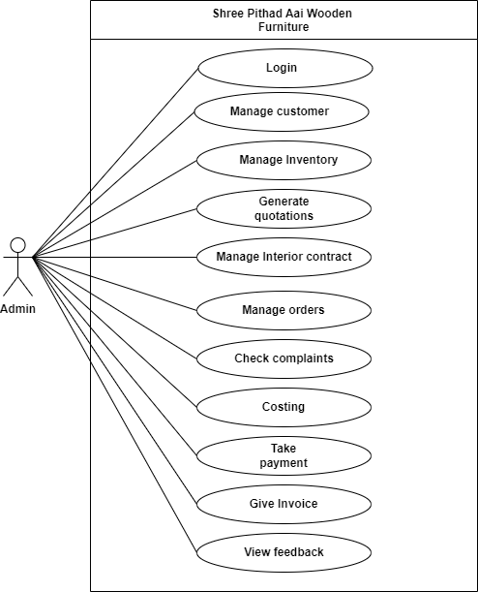

* **Customer Use Case Diagram: -**

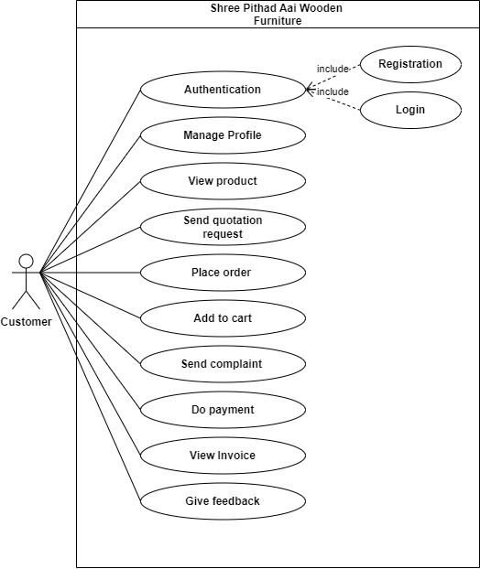

* **Visitor Use Case: -**

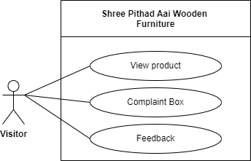

* Class diagram: -

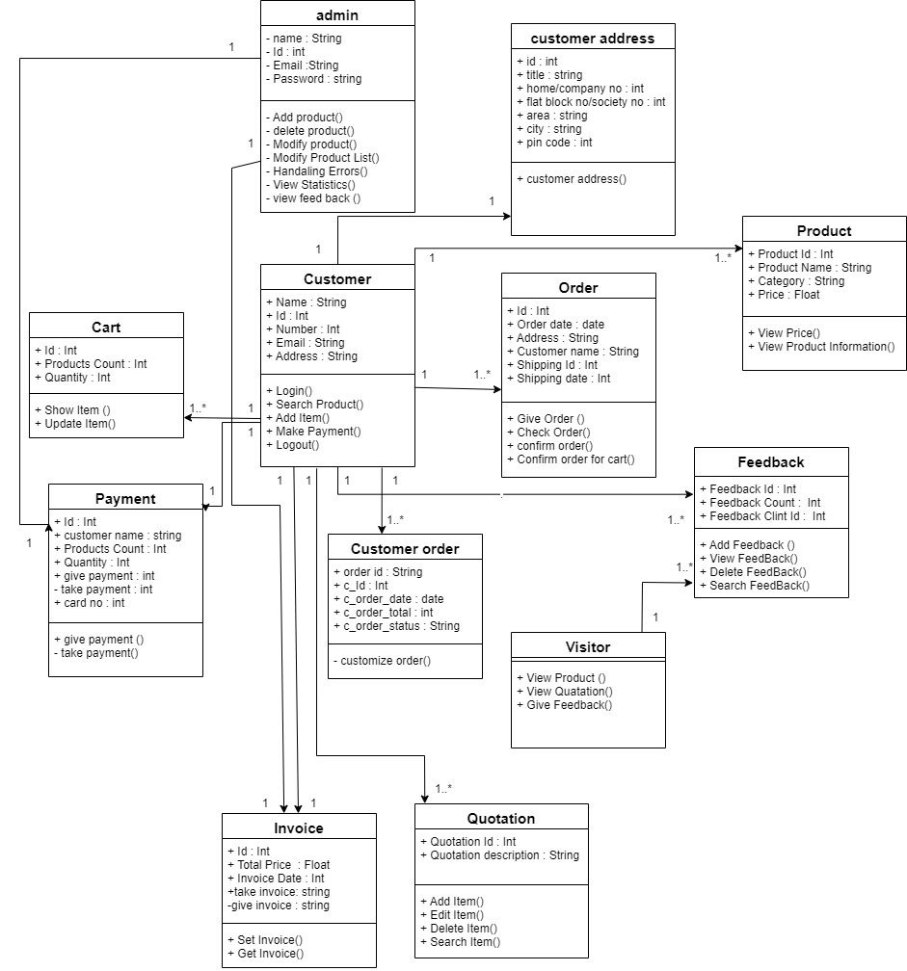

* **Sequence Diagram: -**
* **Registration Sequence Diagram: -**

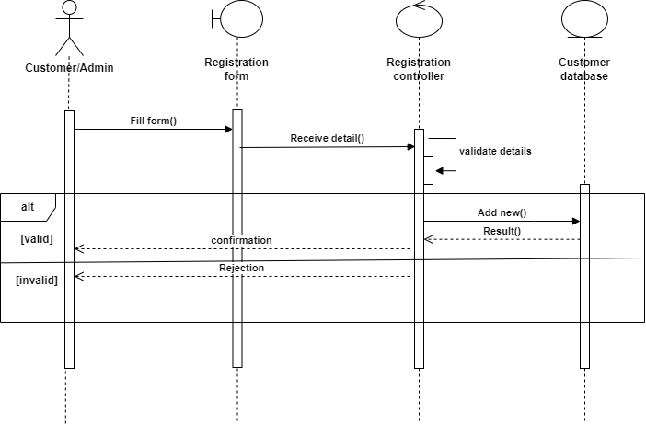

* **Login Sequence Diagram: -**

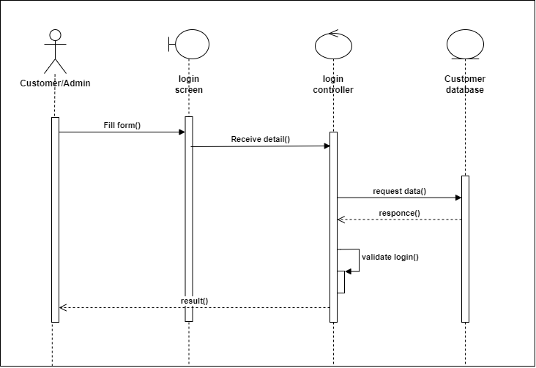

* **Product Sequence Diagram: -**

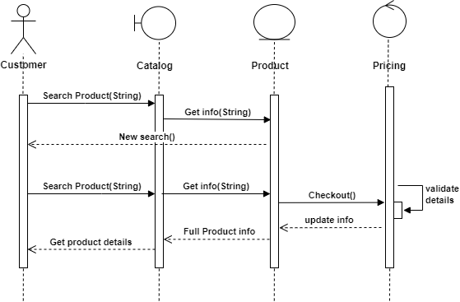

* **Activity Diagram:­ -**

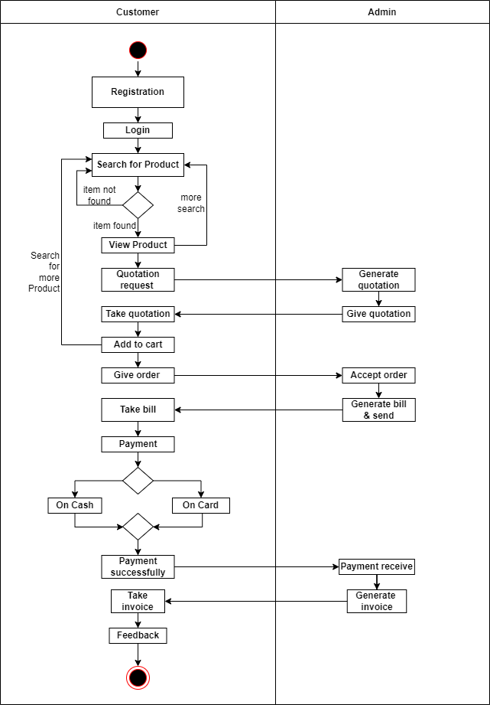

* **State-chart Diagram: -**

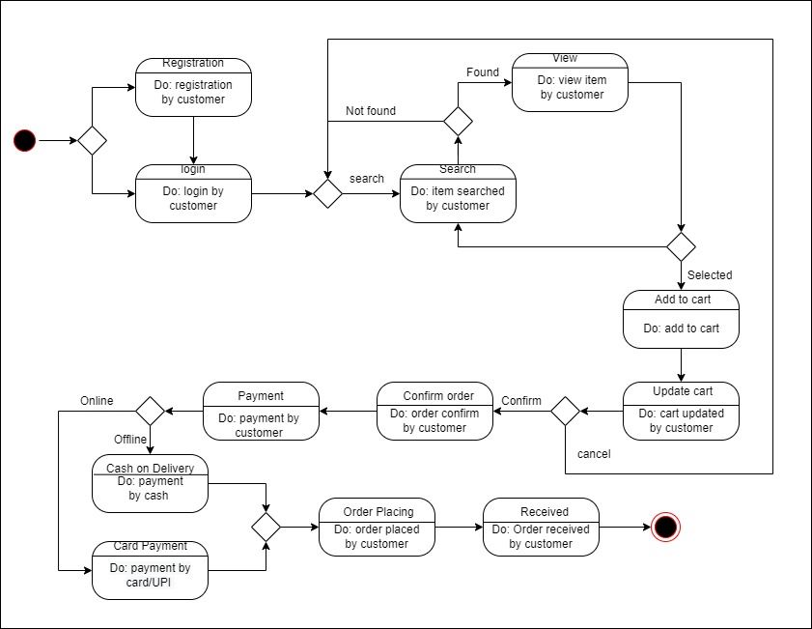

**3.Data Dictionary: -**

* **Admin table: -**

**Primary key: - admin id.**

**Description: - It stores admin data.**

|  |  |  |  |  |  |
| --- | --- | --- | --- | --- | --- |
| No | Field | Datatype | Size | Constraint | Description |
| 1 | a_id | int | 6 | primary key | It stores admin id. |
| 2 | a_name | varchar | 10 | not null | it stores  admin’s name. |
| 3 | C_email | varchar | 10 | not null | It stores email of |
| 4 | C_Password | varchar | 12 | not null | it stores  admin’s password. |

Example: -

|  |  |  |  |
| --- | --- | --- | --- |
| Admin id | Name | Email | Password |
| 1 | darshan | [Ds1@gmail.com](mailto:Ds1@gmail.com) | darshan@1234 |
| 2 | parth | parth211@gmail.com | parth0211 |

* **Customer table: -**

**Primary key: - customer Id.  
Description: - it stores customer data.**

|  |  |  |  |  |  |
| --- | --- | --- | --- | --- | --- |
| No | Field | Datatype | Size | Constraint | Description |
| 1 | C_id | int | 6 | Primary key | It stores customer id. |
| 2 | C_name | varchar | 10 | not null | it stores  customer username. |
| 3 | C_email_id | varchar | 10 | not null | it stores  customer email. |
| 4 | C_password | varchar | 12 | not null | It stores password of customer a/c. |
| 5 | C_contact no | varchar | 10 | not null | it stores  customer contact no. |
| 6 | C_gender | varchar | 6 | not null | it stores  customer gender. |
| 7 | C_dob | date | None | not null | It is stores customer date of birth. |

**Example: -**

|  |  |  |  |  |  |  |
| --- | --- | --- | --- | --- | --- | --- |
| Id | Name | Email | Password | Contact no | Gender | DOB |
| 1 | Ankit | ankit@gmail.com | Anku24 | 2958392747 | Male | 05-02-2003 |
| 2 | mansi | mansi@  gmail.com | mansi29 | 1937482947 | Female | 02-11-2003 |
| 3 | jitu | jitu@gmail.  Com | Jitu2423 | 6928471903 | Male | 08-10-2001 |
| 4 | appu | Appu@gmail.  com | appu1234 | 0987293721 | Male | 05-1-2005 |
| 5 | aakashi | aakashi@  gmail.com | aakashi1029 | 1029384756 | Female | 02-4-2001 |

* **Customer Address table: -  
    
  Primary key: - customer Address Id.**

**Foreign key:- customer id.**

**Foreign key:- customer address id.  
Description: - It stores customer address data.**

|  |  |  |  |  |  |
| --- | --- | --- | --- | --- | --- |
| No | Field | Datatype | Size | Constraint | Description |
| 1 | C_a_id | Int | 6 | Primary key | It stores customer address id. |
| 2 | C_id | Int | 6 | Foreign key | It stores customer id. |
| 3 | C_o_id | int | 6 | Foreign key | It stores customer order id. |
| 4 | C_a_title | varchar | 10 | Not null | It keeps the address's title. |
| 5 | c_a_home/  Company no | int | 4 | Not null | It keeps company and house numbers. |
| 6 | C_a_flat block no / society no | varchar | 2 | none | It keeps the customer's house, flat, or society number. |
| 7 | C_a_area | varchar | 30 | Not null | It stores customer's residence. |
| 8 | C_a_city | Varchar | 10 | Not null | The city where the customer resides is stored. |
| 9 | C_a_pincode | int | 6 | Not null | The address pin code is stored. |

**Example: -**

|  |  |  |  |  |  |  |  |  |
| --- | --- | --- | --- | --- | --- | --- | --- | --- |
| Address id | Customer id | Order id | Title | Home/company no. | Flat block no / society no | Area | City | Pincode |
| 111 | 101 | 1011 | Home | 203 | H | Ghodasar | Ahmedabad | 382445 |
| 112 | 102 | 1012 | Home | 206 | R | vastral | Ahmedabad | 382445 |
| 113 | 103 | 1013 | Compony | 1 | A | Nikol | Ahmedabad | 382445 |
| 114 | 104 | 1014 | Home | 5 | H | Vastral | Ahmedabad | 382445 |
| 115 | 105 | 1015 | home | 27 | W | naroda | Ahmedabad | 382445 |

* **Customer order table: -**  
    
  **Primary key: - customer order Id.**

**Foreign key:- customer id.  
Description: - It stores customer order data.**

|  |  |  |  |  |  |
| --- | --- | --- | --- | --- | --- |
| No | Field | Datatype | Size | Constraint | Description |
| 1 | C_order_id | Int | 6 | Primary key | It stores customer order id. |
| 2 | C_id | Int | 6 | Foreign key | It stores customer id. |
| 3 | C_order_date | Date | None | Not null | It stores order date. |
| 4 | C_order_total | Int | 10 | Not null | It stores total amount of order. |
| 5 | C_order_status | varchar | 10 | Not null | It stores status of order. |

|  |  |  |  |  |
| --- | --- | --- | --- | --- |
| Order id | Customer id | Order date | Total order | Order status. |
| 1 | 101 | 20-10-2022 | 18000 | Pending |
| 2 | 102 | 14-09-2022 | 10000 | Pending |
| 3 | 103 | 30-10-2012 | 20000 | delivered |
| 4 | 104 | 14-09-2016 | 30500 | Pending |
| 5 | 105 | 20-01-2020 | 20000 | delivered |

**Example:-**

* **Order table: -  
    
  Primary key: - Order Id.**

**Foreign key:-product id.**

**Foreign key:-customer id.**

**Foreign key:-customer address id.  
Description: - it is store Order data.**

|  |  |  |  |  |  |
| --- | --- | --- | --- | --- | --- |
| No | Field | Datatype | Size | Constraint | Description |
| 1 | O_id | Int | 6 | Primary key | It stores order id. |
| 2 | p _id | Int | 6 | Foreign key | It stores Product id. |
| 3 | C_id | Int | 6 | Foreign key | It store customer id. |
| 4 | C_a_id | Int | 6 | Foreign key | It stores customer address id. |
| 5 | O_Quantity | int | 5 | Not null | It store product quantity. |
| 6 | O_rate | int | 10 | Not null | It stores product rate. |
| 7 | O_order_date | Date | None | Not null | It stores date of order. |
| 8 | O_Shipping_id | Id | 10 | Not null | It stores order shipping id. |
| 9 | O_Shipping_date | Date | none | Not null | It stores order shipping date. |

**Example: -**

|  |  |  |  |  |  |  |  |  |
| --- | --- | --- | --- | --- | --- | --- | --- | --- |
| Id | Product_id | Customer_  Id | Customer address_id | Quantity | Rate | Order_date | Shipping_id | Shipping_date |
| 2011 | 1001 | 1 | 111 | 1 | 28000 | 12-11-2022 | 1022 | 22-11-2022 |
| 2012 | 1002 | 2 | 112 | 2 | 40000 | 28-04-2020 | 1023 | 10-05-2020 |
| 2013 | 1003 | 3 | 113 | 1 | 30000 | 12-01-2018 | 1024 | 22-01-2018 |
| 2014 | 1004 | 4 | 114 | 2 | 13000 | 28-07-2012 | 1025 | 08-08-2012 |
| 2015 | 1005 | 5 | 115 | 1 | 23000 | 01-03-2013 | 1026 | 11-03-2013 |

* **Product table: -**  
    
  **Primary key: - Product Id.  
  Description: - it is store Product data.**

|  |  |  |  |  |  |
| --- | --- | --- | --- | --- | --- |
| No | Field | Datatype | Size | Constraint | Description |
| 1 | P_id | int | 6 | Primary key | It stores product id. |
| 2 | P_name | varchar | 10 | not null | It stores product name. |
| 3 | P_color | varchar | 8 | Not null | It stores product color. |
| 4 | P_height | Float | 6 | Not null | It store product height. |
| 5 | P_width | Float | 6 | Not null | It store product width. |
| 6 | P_length | Float | 6 | Not null | It store product length. |
| 4 | P_quantity | int | 5 | Not null | It stores quantity. |
| 5 | P_desc | varchar | 200 | not null | it stores product description. |
| 6 | P_price | int | 10 | Not bull | It stores product price. |
| 7 | P_warranty time | date | none | Not null | It stores product warranty. |

|  |  |  |  |  |  |  |  |  |  |  |  |
| --- | --- | --- | --- | --- | --- | --- | --- | --- | --- | --- | --- |
| Id | Category | Name | Image | Color | Height | width | length | Quantity | Description | Price | Warranty |
| 1001 | Bed | Beds |  | Brown | 3 | 6 | 6 | 1 | A bed is an item of furniture. | 18,000/-  -  40,000/- | 5 years after Purchase date. |
| 1002 | Cabinet | Cabinets |  | walnut | 4.2 | 2 | 2.3 | 1 | A cabinet is a piece of furniture that has doors and drawers and is often used for storage. | 5000/-  -  60,000/- | 5 years after Purchase date. |
| 1003 | Chair | Chair |  | Brown | 4 | 1.3 | 1.3 | 2 | Seats are a versatile form of furniture that is mandatory at home and office. They are useful for retaxing and working. | 2000/-  -  6000/- | 5 years after Purchase date. |
| 1004 | Table | coffee  Table |  |  | 2 | 2.6 | 3 | 1 | an article of furniture consisting of a flat, slab like top supported on one or more legs or other supports. | 5000/-  -  25000/- | 5 years after Purchase date. |
| 1005 | Sofa | Sofa |  | Gray | 4.3 | 11 | 3.8 | 1 | A sofa is a long, comfortable seat with a back and usually with arms, which two or three people can sit on. | 15000/-  -  100000/- | 5 years after Purchase date. |

**Example: -**

* **Quotation table: -**

**Primary key: - Quotation Id.**

**Foreign key:- product id.  
Description: - it is store Quotation data.**

|  |  |  |  |  |  |
| --- | --- | --- | --- | --- | --- |
| No | Field | Datatype | Size | Constraint | Description |
| 1 | Q_id | Int | 6 | Primary key | It is a store quid. |
| 2 | P_id | int | 6 | Foreign key | It stores product id. |
| 3 | Q_product_  Name | Varchar | 10 | Not null | It is a store product name. |
| 4 | Q_product_  Price | Int | 10 | Not null | It is a store product price. |
| 5 | Q_product_  Width | Float | 4 | Not null | It is a store product width. |
| 6 | Q_product_  Height | Float | 4 | Not null | It is a store product height. |
| 7 | Q_product_  Length | Float | 4 | Not null | It is a store product length. |
| 8 | Q_woodtype | Varchar | 10 | Not null | It is a store product wood type &  Price. |
| 9 | Q_material | Varchar | 10 | Not null | It is a store product material  & price. |
| 10 | Q_product_  description | varchar | 200 | Not null | It stores product description. |
| 11 | Q_total price | int | 10 | Not null | It is a store total price. |

|  |  |  |  |  |  |  |  |  |  |  |
| --- | --- | --- | --- | --- | --- | --- | --- | --- | --- | --- |
| Id | Product id | Product Name | Product Price | Product Width | Product Height | Product length | Wood  type &  price | Material | Product description | Total  Price |
| 1011 | 1001 | Beds. | 28,000 | 6.3 | 1.25 | 6 | Teak | ceramic | A bed is an item of furniture. | 35,000 |
| 1012 | 1002 | Cabinets. | 6,000 | 3 | 3.5 | 2.5 | Teak | glass | A cabinet is a piece of furniture. | 8,000 |
| 1013 | 1003 | Chair | 3,000 | 1 | 4 | 1.2 | Oak | seat | They are useful for retaxing and working. | 3800 |
| 1014 | 1004 | Table | 15,000 | 4.5 | 4.8 | 4.2 | Ash | Formica | such a piece of furniture used for serving food to those seated at it. | 15000 |
| 1015 | 1005 | Sofa | 25000 | 4.3 | 11 | 3.8 | Maple | Seating cushion | A sofa is a long, comfortable seat with a back and usually with arms | 3000 |

**Example: -**

* **Payment table: -**

**Primary key :- product Id.**

**Foreign key :-customer id.**

**Foreign key :- order id.**

**Foreign key :- quotation id.**

**Foreign key :-customer address id.  
Description: - It stores payment data.**

|  |  |  |  |  |  |
| --- | --- | --- | --- | --- | --- |
| No | Field | Datatype | Size | Constraint | Description |
| 1 | Pay_id | Int | 6 | Primary Key | It stores payment id. |
| 2 | C_id | int | 6 | Foreign key | It stores customer id. |
| 3 | O_id | Int | 6 | Foreign key | It stores order id. |
| 4 | Q_id | Int | 6 | Foreign key | It stores Quotation id. |
| 5 | C_a_id | Int | 6 | Foreign key | It stores customer address id. |
| 6 | Pay_amount | Varchar | 10 | Not null | It stores payment amount. |
| 7 | Pay_date | date | none | Not null | It keeps the time and date of payments. |
| 8 | Pay_type | varchar | 20 | Not null | It stores Type of payment. |

**Example: -**

|  |  |  |  |  |  |  |  |
| --- | --- | --- | --- | --- | --- | --- | --- |
| Payment id | Customer id | Order id | Quotation id | Customer address id | Date | Type | Address |
| 1 | 1 | 20011 | 2011 | 1 | 27-20-2022 | cash on delivery | a/11, Gokul platinum, jasoda Nagar, Ahmedabad. |
| 2 | 2 | 20012 | 2012 | 2 | 17-10-2022 | Online payment | a/11, Gokul platinum, jasoda Nagar, Ahmedabad. |
| 3 | 3 | 20013 | 2013 | 3 | 27-20-2022 | Online  payment | a/11, Gokul platinum, jasoda Nagar, Ahmedabad. |
| 4 | 4 | 20014 | 2014 | 4 | 17-10-2022 | cash on delivery | a/11, Gokul platinum, jasoda Nagar, Ahmedabad. |
| 5 | 5 | 20015 | 2015 | 5 | 27-20-2022 | Online payment | a/11, Gokul platinum, jasoda Nagar, Ahmedabad. |

* **Invoice table: -  
    
  Primary key: - Quotation Id.**

**Foreign key:- customer id.**

**Description: - it is store Quotation data.**

|  |  |  |  |  |  |
| --- | --- | --- | --- | --- | --- |
| No | Field | Datatype | Size | Constraint | Description |
| 1 | I_id | Int | 6 | Primary key | It stores invoice id. |
| 2 | I_Product_  Name | Varchar | 10 | Not null | It stores product name. |
| 3 | C_id | int | 6 | Foreign key | It stores customer’s id. |
| 4 | I_Total_price | Int | 10 | Not null | It stores product total price. |
| 5 | I_invoice_date | Date | None | Not null | It stores invoice date. |
| 6 | I_warranty_  date | date | none | Not null | It Stores  Furniture warranty date. |

**Example: -**

|  |  |  |  |  |  |
| --- | --- | --- | --- | --- | --- |
| Id | Product Name | Customer id | Total Price | Invoice Date | Warranty Date |
| 1023 | Beds. | 1 | 28,000 | 10-12-2016 | 5 Year After Purchase Date |
| 1024 | Cabinets. | 2 | 12,000 | 14-2-2014 | 5 Year After Purchase Date |
| 1025 | Chair | 3 | 3000 | 01-05-2022 | 5 Year After Purchase Date |
| 1026 | Table | 4 | 15000 | 03-08-2020 | 5 Year After Purchase Date |
| 1027 | Sofa | 5 | 25000 | 14-12-2022 | 5 Year After Purchase Date |

* **Feedback Table: -  
    
  Primary key: - Feedback Id.**

**Foreign key:- customer id.  
Description: - it is store feedback data.**

|  |  |  |  |  |  |
| --- | --- | --- | --- | --- | --- |
| No | Field | Datatype | Size | Constraint | Description |
| 1 | F_id | Int | 6 | Primary Key | It stores id of feedback. |
| 2 | C_id | Int | 6 | Foreign key | It stores customer’s id. |
| 3 | F_date | Date | None | Not null | It stores date of feedback. |
| 4 | F_feedback | varchar | 200 | Not null | It stores details about all feedback. |

* **Example:**

|  |  |  |  |
| --- | --- | --- | --- |
| Feedback id | Customer id | Date | Feedback |
| 1 | 101 | 04-01-2022 | I love this product. |
| 2 | 102 | 06-11-2022 | This product is not well. |
| 3 | 103 | 07-12-2022 | I love this product. |
| 4 | 104 | 22-03-2022 | This product is not well. |
| 5 | 105 | 19-10-2022 | I love this product. |